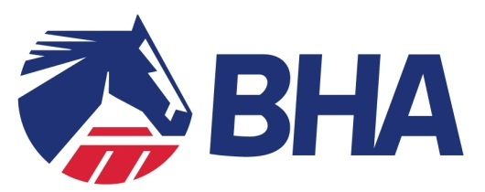

TRANSFER OF RESPONSIBILITY
Under the Rules of Racing

TO BE COMPLETED BY THE TRAINER

This form must be completed by the Trainer, to transfer his responsibility as a Responsible Person under the Equine Anti-Doping Manual to the Owner, when the horse goes out of his care or control.

Please complete the following details:

Name of Horse
(if unnamed, please give Pedigree details)
Date of Transfer
Details of Transfer
(e.g. owner to collect, sent to XX on owner’s instructions)
Address of Owner
Contact Details of Owner
(Telephone/Email)

NAME: . . . . . . . . . . . . . . . . . . . . . . . . . . . . . .
SIGNED . . . . . . . . . . . . . . . . . . . . . . . . . . . . . . . . . .(TRAINER/TRAINER’S REPRESENTATIVE)
*delete as appropriate

NAME: . . . . . . . . . . . . . . . . . . . . . . . . . . . . . .

SIGNED . . . . . . . . . . . . . . . . . . . . . . . . . . . . . . . . . . . .. . . . . . . . . . (OWNER/OWNER’S AGENT)
*delete as appropriate

GUIDANCE NOTES ON TRANSFER OF RESPONSIBILTY
ATTENTION IS DRAWN TO THE CONSEQUENCES OF BEING A RESPONSIBLE PERSON

Consequences of being the Responsible Person
The Equine Anti-Doping Rules place the burden for compliance with the rules in respect of each horse on the “Responsible Person”.

The Responsible Person is the person which the BHA would pursue for any violations that occur in respect of the horse. This includes:
- If the horse’s urine or blood sample tests positive;
- If the horse has been administered a prohibited substance (even if it was not the Responsible Person who administered it, or if they knew about it);
- If they or anyone else refuses to allow the horse to be tested, or fails to comply with a request for testing;
- If the horse receives its third missed test (provided the responsible person was already aware of the first two missed tests);
- If they receive three filing failures in relation to any horse(s) which are their responsibility.

They are also responsible for providing whereabouts information in relation to the horse. (See information on “Whereabouts” on page 9 of A Guide to the British Horseracing Authority’s Equine Anti-Doping Rules at http://www.britishhorseracing.com/resource-centre/anti-doping-medication-control/equine-anti-doping-rules-and-guidance/).

What steps must be taken by the owner on receipt of this form?
An owner should promptly respond to the trainer consenting to the transfer of responsibility, where the horse has been moved to a location on their instruction. This can be done by signing this form and returning it, or by emailing, faxing or writing to the trainer.

If the owner had concerns that the horse is not in actual fact moving into his care or control, he should contact the trainer in the first instance to come to agreement on who is the Responsible Person. If the owner and trainer cannot come to agreement, they should email BHA at anti-doping@britishhorseracing.com with details of the issue, and include a copy of this form.

If the owner does not respond to the trainer and accept this transfer, but the trainer can establish that he took reasonable steps to obtain the owner’s acceptance, then responsibility will shift to the owner.

More information can be found in A Guide to the British Horseracing Authority’s Equine Anti-Doping Rules at http://www.britishhorseracing.com/resource-centre/anti-doping-medication-control/equine-anti-doping-rules-and-guidance/.

